4_ Secure management plane.

Aim: Secure management plane.
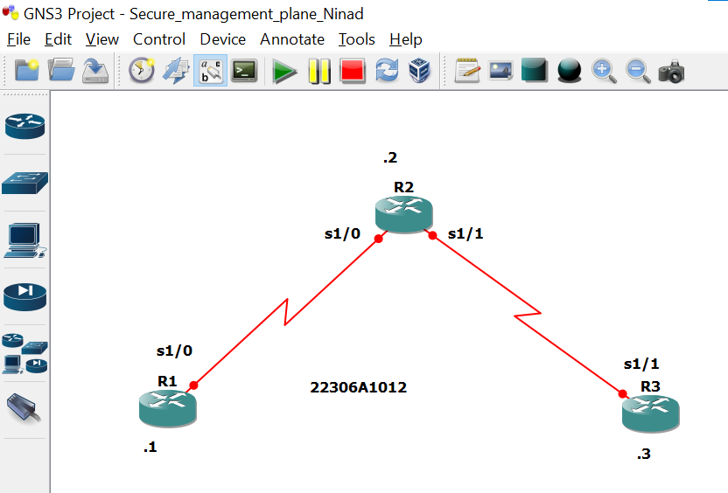
Take 3 routers -> Configure -> slots -> NM-4T
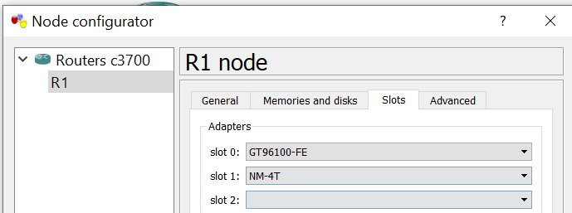
R1 Console
R1 #
R1 # conf t
Enter configuration commands, one per line. End with CNTL/Z.
R1(config) # int s1/0
R1(config-if) # ip add 10.1.1.1 255.255.255.0
R1(config-if) # no sh

R1(config-if) # int lo0
R1(config-if) # ip add 192.168.1.1 255.255.255.0
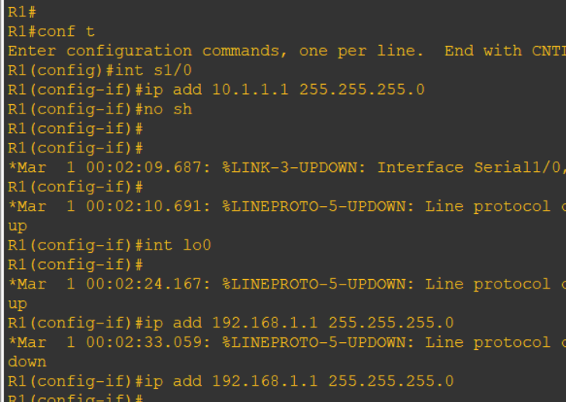
R2 Console
R2 # conf t
R2(config) # int s1/0
R2(config-if) # ip add 10.1.1.2 255.255.255.0
R2(config-if) # no sh

R2(config-if) # int s1/1
R2(config-if) # ip add 10.2.2.2 255.255.255.0
R2(config-if) # no sh
R2(config-if) #
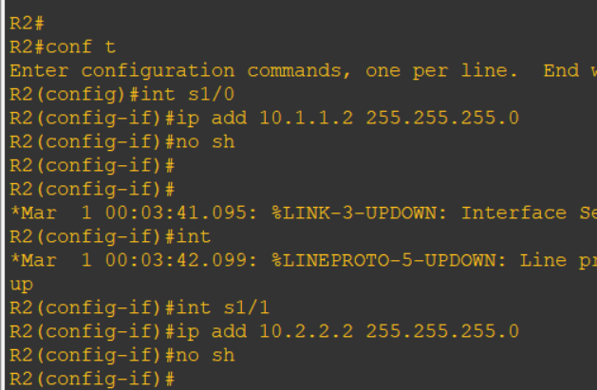
R3 Console
R3 # conf t
R3(config) # int s1/1
R3(config-if) # ip add 10.2.2.3 255.255.255.0
R3(config-if) # no sh
R3(config-if) #
R3(config-if) # int lo0
R3(config-if) # ip add 192.168.3.3 255.255.255.0
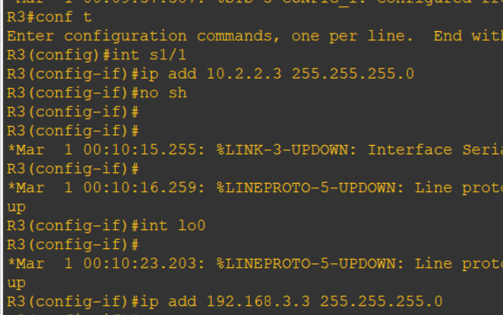
Part 2 : Routing
R1 Console
R1(config-if) # exit
R1(config) #
R1(config) # ip route 0.0.0.0 0.0.0.0 10.1.1.2
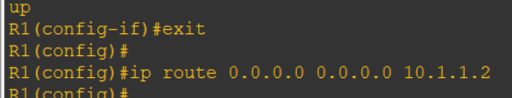

R2 Console
R2(config-if) # exit
R2(config) #
R2(config) # ip route 192.168.1.0 255.255.255.0 10.1.1.1
R2(config) # ip route 192.168.3.0 255.255.255.0 10.2.2.3
R2(config) #
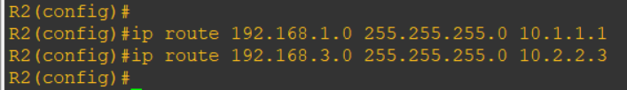

R3 Console
R3(config-if) # exit
R3(config) #
R3(config) # ip route 0.0.0.0 0.0.0.0 10.2.2.2
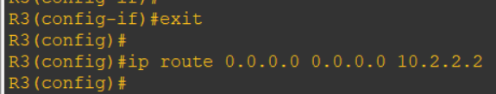
Ping
R1 Console
R1(config) # do ping 192.168.3.3
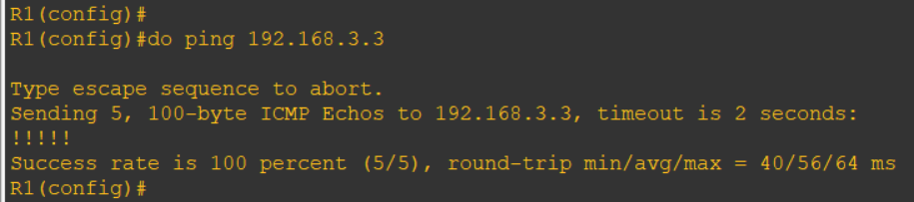
R3 Console
R3(config) # do ping 192.168.1.1
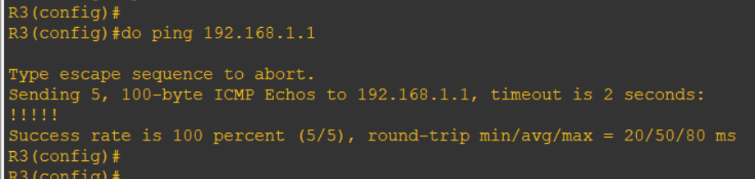

Part 3: Security Management Access
R1 Console
r1(config) # hostname r1
r1(config) # security password min-length 10
r1(config) # enable secret class12345
r1(config) #
r1(config) # line console 0
r1(config-line) # password ciscoconpass
r1(config-line) # exec-timeout 5 0
r1(config-line) # login
r1(config-line) # logging synchronous
r1(config-line) # exit
r1(config) #
r1(config) # line vty 0 4
r1(config-line) # password ciscovtypass
r1(config-line) # exec-timeout 5 0
r1(config-line) # login
r1(config-line) # exit
r1(config) #
r1(config) # line aux 0
r1(config-line) # no exec
r1(config-line) # end

r1 # conf t
Enter configuration commands, one per line. End with CNTL/Z.
r1(config) # service password-encryption
r1(config) # banner motd $Unauthorized access not allowed$
r1(config) # exit

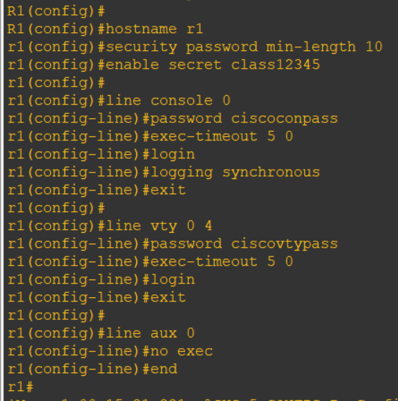
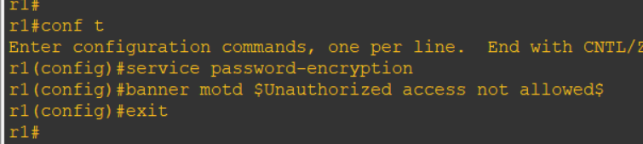

R3 Console ( Same as R1)
R3(config) # hostname r3
r3(config) # security password min-length 10
r3(config) # enable secret class12345
r3(config) # line console 0
r3(config-line) # password ciscoconpass
r3(config-line) # exec-timeout 5 0
r3(config-line) # login
r3(config-line) # logging synchronous
r3(config-line) # exit
r3(config) # line vty 0 4
r3(config-line) # password ciscovtypass
r3(config-line) #
r3(config-line) #
r3(config-line) #
r3(config-line) # exec-timeout 5 0
r3(config-line) # login
r3(config-line) # exit
r3(config) #
r3(config) # line aux 0
r3(config-line) # no exec
r3(config-line) # end
r3 #
r3 # conf t
r3(config) # service password-encryption
r3(config) # banner motd $Unauthorized access not allowed$
r3(config) # exit
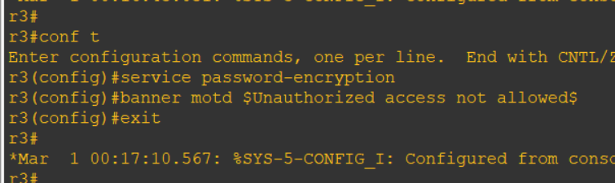

R3 Console
r3 # telnet 10.1.1.1

(password-> ciscovtypass)
